ATAR Physics Year 12
Semester Two Examination, 2016
Question/Answer Booklet

Student Name: ___________________________________

Time allowed for this paper
Reading time before commencing work: 10 minutes
Working time for paper: 3 hours

Materials required/recommended for this paper
To be provided by the supervisor
This Question/Answer Booklet and the Formulae and Constants Sheet

To be provided by the candidate
Standard items: pens (blue/black preferred), pencils (including coloured), sharpener, correction tape/fluid, eraser, ruler, highlighters
Special items: non-programmable calculators approved for use in the WACE examinations, drawing templates, drawing compass and a protractor

Important note to candidates
No other items may be taken into the examination room. It is your responsibility to ensure that you do not have any unauthorised notes or other items of a non-personal nature in the examination room. If you have any unauthorised material with you, hand it to the supervisor before reading any further.

Structure of this paper
Section | Number of questions available | Number of questions to be answered | Suggested working time (minutes) | Marks available | Marks Attained
Section One: Short answers | 13 | 13 | 54 | 54 (30%) | /54
Section Two: Problem-solving | 7 | 7 | 90 | 90 (50%) | /90
Section Three: Comprehension | 2 | 2 | 36 | 36 (20%) | /36
 |  |  |  | 180 (100%) | /180

Instructions to candidates
Write your answers in the spaces provided beneath each question. The value of each question (out of 180) is shown following each question.
The enclosed Physics: Formulae and Constants Sheet may be removed from the booklet and used as required.
Calculators satisfying conditions set by the Curriculum Council may be used to evaluate numerical answers.
Answers to questions involving calculations should be evaluated and given in decimal form.
Give final answers to three significant figures and include appropriate units where applicable.
When calculating numerical answers, show your working or reasoning clearly. Despite an incorrect final answer, credit may be obtained for method and working, providing this is clearly and legibly set out.
Questions containing specific instructions to show working should be answered with a complete, logical, clear sequence of reasoning showing how the final answer was arrived at; correct answers which do not show working will not be awarded full marks.
Questions containing the instruction estimate may give insufficient numerical data for their solution. Students should provide appropriate figures to enable an approximate solution to be obtained. When estimating numerical answers, show your working or reasoning clearly. Give final answers to a maximum of two significant figures and include appropriate units where applicable.
SECTION ONE: Short Response 54 marks (30%)
This section has 15 questions. Answer ALL questions. Write your answers in the spaces provided.
Spare pages are included at the end of this booklet. They can be used for planning your responses and/or as additional space if required to continue an answer.
- Planning: If you use the spare pages for planning, indicate this clearly at the top of the page.
- Continuing an answer: If you need to use the space to continue an answer, indicate in the original answer space where the answer is continued, i.e. give the page number.
Fill in the number of the question(s) that you are continuing to answer at the top of the page.
Suggested working time for this section is 50 minutes.

Question 1 (4 marks)
The diagram below shows a simple AC generator, rotating at a frequency of 10 Hz. On the axes provided below, sketch the magnetic flux φ through the coil and also the emf ε induced as the coil rotates, starting from the position shown in the diagram.
φ
t(s)
0.2
0.1
ε
t(s)
0.2
0.1

Question 2 (3 marks)
A long jumper at the Rio Olympics launches himself into the air at a speed of 11.0 m/s and an angle of 22.5° to the horizontal in an attempt to beat the world record of 8.95 metres. Ignoring air resistance, show by calculation whether or not he is successful.

Question 3 (4 marks)
The relatively nearby star Tau Ceti, which is the closest solitary G-class star like our Sun, lies 11.9 light-years from Earth, and has five exoplanets, two of which lie in the "habitable zone" — that just-right range of distances that could support the existence of liquid water on the planets' surfaces. An interstellar spaceship from Earth is travelling to Tau Ceti at 90% of the speed of light.
(a) How far away is Tau Ceti (in light-years) to the astronauts on the spaceship? (2 marks)

(b) How long will the spaceship take to reach Tau Ceti
(i) from the reference frame of observers on Earth? (1 mark)

(ii) from the reference frame of the astronauts on the spaceship? (1 mark)

Question 4 (3 marks)
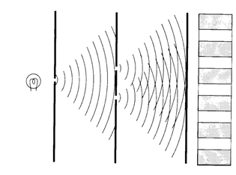
The diagram at right illustrates Young’s famous double-slit experiment, which was crucial in helping us to understand the nature of light. Briefly describe how the experiment worked, and explain the insight it gave into the nature of light.

Question 5 (4 marks)
A satellite orbits the Earth in a circular orbit at an altitude of 4000 km. Calculate
(a) the centripetal acceleration experienced by the satellite. (2 marks)

(b) the orbital speed of the satellite. (2 marks)

Question 6 (5 marks)
The diagrams below show a long straight vertical wire (diagram A) and a solenoid (diagram B). Arrows indicate the direction of the current through each of the conductors.

A B
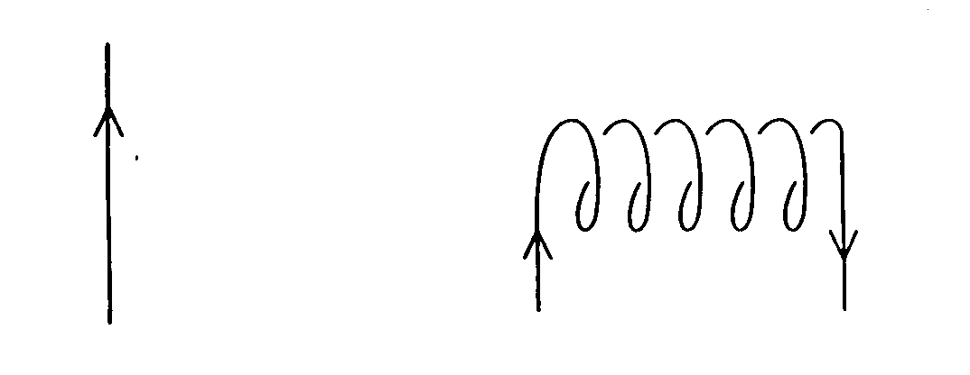

(a) Sketch on each diagram the magnetic field produced by each conductor. (3 marks)
(b) In diagram A the magnetic field strength is found to be 45 μT at a perpendicular distance of 1.75 cm from the long straight wire. Calculate the size of the current in the wire. (2 marks)

Question 7 (5 marks)
A proton is accelerated in the Large Hadron Collider at CERN in Geneva up to 99.995% of the speed of light. At this speed, calculate
(a) the mass of the proton (2 marks)

(b) its momentum (1 mark)

(c) the wavelength of the proton (2 marks)

Question 8 (4 marks)
The diagrams below show the interaction between a bar magnet and a solenoid in three different situations. The needle of the galvanometer, shown below the solenoid, indicates any flow of current.
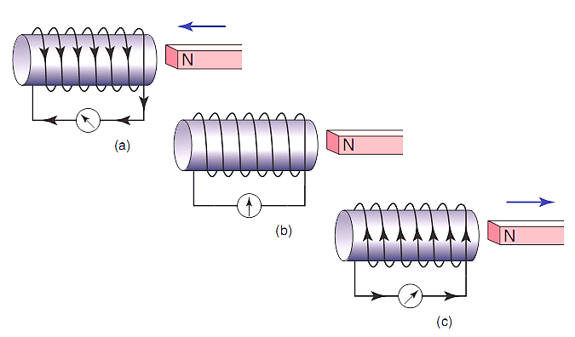

Briefly explain the following observations:
(a) No current flows (diagram b) when the magnet is held stationary near the solenoid. (1 mark)

(b) The current flows in opposite directions in diagrams (a) and (c) when the magnet is pushed towards, then pulled away from the solenoid. (3 marks)

Question 9 (5 marks)
A photoelectric cell contains an aluminium electrode that is illuminated with ultraviolet light of wavelength 284 nm. The work function of aluminium is 4.08 eV. Calculate
(a) the energy of one of the ultraviolet photons in electron-volts. (2 marks)

(b) the velocity of the emitted photo-electrons. (3 marks)

Question 10 (3 marks)
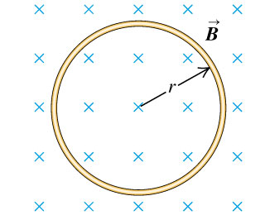
The diagram at right shows a ring of wire of radius r = 2.00 cm, which is fully immersed in a uniform magnetic field B = 50.0 mT. The ring is pulled quickly out of the magnetic field, taking 0.15 s to be clear of the magnetic field.
(a) Indicate on the ring the direction of any induced current.
(1 mark)

(b) If the ring has a resistance of 0.03 Ω, find the size of the average current induced as the ring is pulled clear of the magnetic field. (2 marks)

Question 11 (5 marks)
Observations of the luminosity of a supernova in a distant galaxy indicate that it is 50 mega parsecs away from Earth. Analysis of the helium spectrum from the supernova shows that the yellow line that usually occurs at a wavelength of 587.6 nm was measured for this galaxy to be at 595.3 nm.

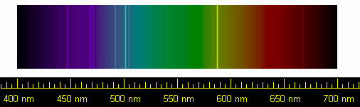

(a) What has caused this change in wavelength of the yellow line in the helium spectrum for this distant galaxy? (1 mark)

(b) The recessional velocity of a galaxy can be calculated from spectral data using
$$v=\frac{∆λ}{λ_{0}}c$$
where $∆λ$ is the difference in the wavelength and $λ_{0}$ is the wavelength when measured at rest with the light source. Calculate the velocity of the galaxy containing the supernova. (2 marks)

(c) Use the data from this galaxy to estimate a value for Hubble’s constant H_{o}. (2 marks)

Question 12 (5 marks)
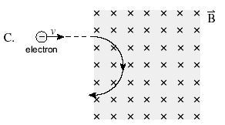An electron is fired into a uniform perpendicular magnetic field of strength 230 μT and follows a semi-circular path through the magnetic field of radius 350 mm, as illustrated at right.

(a) Calculate the speed needed for the electron to follow the semi-circular path. You may ignore any relativistic effects. (2 marks)

(b) Determine the potential difference through which the electron was accelerated (before reaching the magnetic field) in order to have this speed. (3 marks)

Question 13 (4 marks)
There are 6 different quarks, which are shown in the table below. Quarks interact strongly with one another and exist in combination as composite particles called hadrons. There are two classes of hadrons – baryons, made of three quarks, and mesons, made of a quark-antiquark pair.

NAME | SYMBOL | Charge (Q) | Baryon Number (B) | Strangeness (S) | Charm  (c) | Bottomness (b) | Topness  (t)
Up | u | $+\frac{2}{3}$ e | $$\frac{1}{3}$$ | 0 | 0 | 0 | 0
Down | d | $-\frac{1}{3}$ e | $$\frac{1}{3}$$ | 0 | 0 | 0 | 0
Strange | s | $-\frac{1}{3}$ e | $$\frac{1}{3}$$ | -1 | 0 | 0 | 0
Charm | c | $+\frac{2}{3}$ e | $$\frac{1}{3}$$ | 0 | +1 | 0 | 0
Bottom | b | $-\frac{1}{3}$ e | $$\frac{1}{3}$$ | 0 | 0 | -1 | 0
Top | t | $+\frac{2}{3}$ e | $$\frac{1}{3}$$ | 0 | 0 | 0 | +1

(a) Compare the baryon number for the tow different types of hadrons. (2 marks)

(b) Give the quark composition of each of the following hadrons: (2 marks)
(i) the baryon Σ⁰ which has Q = 0, B = 1, S = -1 and c = b = t = 0

(ii) the meson K⁺ which has Q = +1, B = 0, S = +1 and c = b = t = 0

End of Section One

SECTION TWO: Problem-solving 90 marks (50%)
This section has 7 questions. Answer ALL questions. Write your answers in the spaces provided.
Spare pages are included at the end of this booklet. They can be used for planning your responses and/or as additional space if required to continue an answer.
- Planning: If you use the spare pages for planning, indicate this clearly at the top of the page.
- Continuing an answer: If you need to use the space to continue an answer, indicate in the original answer space where the answer is continued, i.e. give the page number. Fill in the number of the question(s) that you are continuing to answer at the top of the page.
Suggested working time for this section is 90 minutes.

Question 16 (12 marks)
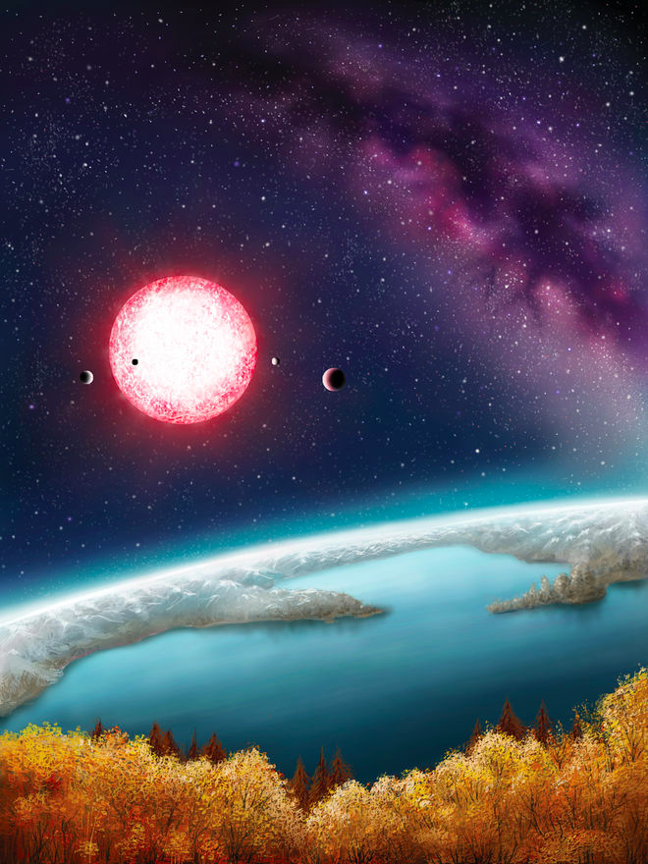
Kepler-186f is one of five planets found in an extrasolar system located about 490 light-years from Earth. The newly discovered exoplanet orbits about 52.4 million kilometres from its sun. It takes Kepler-186f about 130 days to orbit its red dwarf star. Kepler-186f is the first Earth-size alien planet found in the habitable zone of its star. That means the planet, which is about 10% larger in diameter than Earth, is in the part of its solar system where liquid water could exist on the planet's surface. An artist’s impression of the planet’s surface is shown at right.

(a) What is the orbital speed of Kepler-186f?
(2 marks)

(b) Is Kepler-186f accelerating? Explain. (2 marks)

(c) From the orbital data about Kepler-186f, calculate the mass of its red dwarf sun. (3 marks)

(d) Assuming that Kepler-186f has a similar density to Earth, calculate a value for its mass based upon its size. (2 marks)

(e) Hence find a value for the gravitational force between Kepler-186f and its sun. (3 marks)

Question 17 (12 marks)
The series of diagrams below show a very fast train, with a woman standing on an open carriage, speeding at a relativistic velocity past a man standing on the ground next to the train tracks. Just as the train passes the man, two bolts of lightning strike the front and rear of the train.
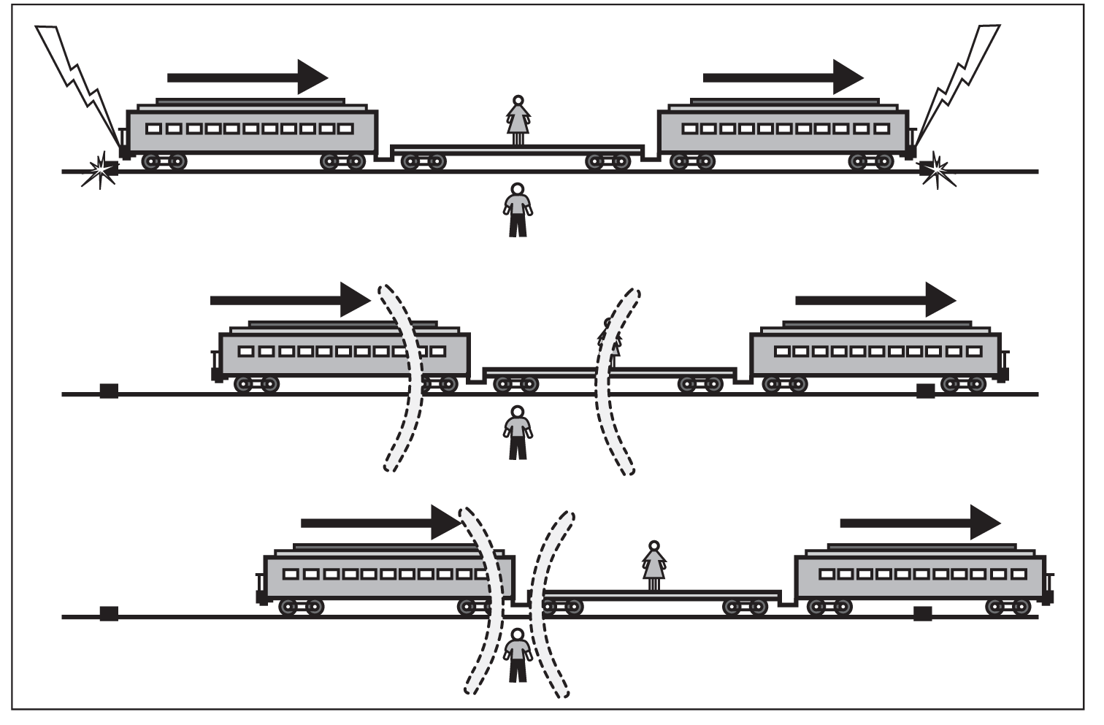

(a) What is the order in time of the two lightning strikes according to
(i) the man standing on the ground. (1 mark)

(ii) the woman standing on the train carriage. (1 mark)

(b) Whose interpretation of events is correct, the man’s or the woman’s? Briefly explain. (2 marks)

(c) How can the man explain the order of the events as observed by the woman? (2 marks)

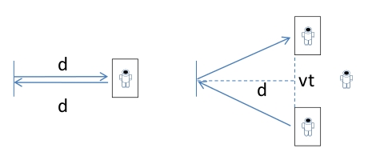
In a futuristic scenario, an astronaut aboard a relativistic spacecraft conducts a simple experiment (diagram A), by shining a beam of light onto a mirror that is a distance d away, and timing how long the reflection takes to return to her. Her value for the time taken by the light to travel to the mirror and back is
A
B
t₀ = 2d/c (equation 1)
While she conducts this simple experiment, a second astronaut observes the experiment from a space station as the relativistic spacecraft speeds past at velocity v. He sees the beam of light follow the path shown in diagram B due to the motion of the spacecraft.
(c) Show that the time he measures for the light travelling to the mirror and back is given by the expression (3 marks)
$t = \frac{2 \sqrt{d^{2}+\frac{1}{4}v^{2}t^{2}}}{c}$ (equation 2)

(d) By combining equations 1 and 2, derive a formula that can be used to calculate $t$ from knowledge of $t_{0}$ (without requiring knowledge of $d$). (3 marks)

Question 18 (13 marks)
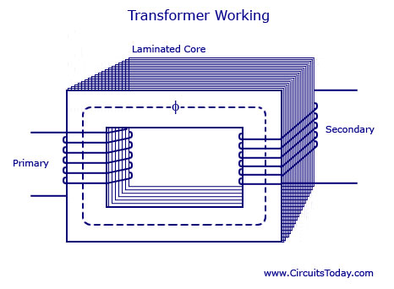The diagram below shows an iron-cored transformer

(a) Explain how energy is transferred from the primary coil to the secondary coil, with reference to Faraday’s Law of electromagnetic induction. (3 marks)

(b) What is a laminated core, and what is its purpose? (2 marks)

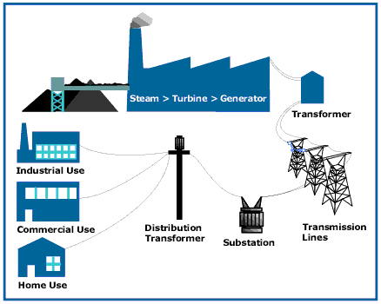
In order to transmit electric power more efficiently, an electricity company uses transformers and high voltage transmission lines to transmit power at 330 kV from the power station to the city 200 km away. The average output power of its generators is 600 MW during the high demand period from 3pm to 9pm on a hot summer day. The high voltage transmission lines have a total resistance of 5.00 Ω over their 200 km length.

(c) What is the voltage at the end of the transmission lines (before the substation) after transmission along the high voltage lines? (3 marks)

(d) Calculate the percentage power loss in the high voltage transmission lines. (2 marks)

(e) Given that the energy content of coal is 24 MJ per kilogram, and that the process of generating electrical energy in a coal fired power station is 40% efficient, calculate the mass of coal needed to supply the electrical energy required during the high demand period from 3pm to 9pm on a hot summer day. (3 marks)

Question 19 (11 marks)
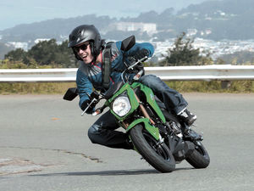
A man rides a motorcycle around a flat curve in the road at a constant speed of 54.0 km/h. The man and motorcycle have a combined mass of 185 kg and the curve has a radius of curvature of 35.0 m. The rider must lean over as he corners.

(a) Show the physical forces acting on the man as he rides the motorcycle around the corner. Use labelled arrows in the picture at right. (2 marks)

(b) Explain why the rider has to lean over as he corners on the motorcycle. (3 marks)

(c) Calculate the force of friction acting on the tyres of the bike. (2 marks)

(d) What is the size of the total force exerted by the road on the tyres? (2 marks)

(e) What is the angle that the bike and rider make to the horizontal? (2 marks)

Question 20 (15 marks)
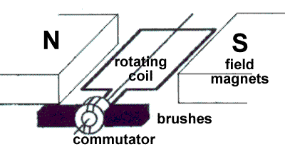
A typical DC electric motor is shown at right. The coil contains 250 turns and has dimensions of 8.00 cm in length by 5.00 cm in width. The field magnets produce a uniform magnetic field of strength 0.0240 T in which the coil rotates.
(a) Explain the purpose of the commutator and brushes. (2 marks)

(b) Describe two ways that an actual electric motor would differ from the one shown in the diagram above. (2 marks)

(c) When in operation under load, the motor rotates at a steady rate of 750 rpm (revolutions per minute) and draws a current of 3.00 A. On the axes below, sketch the torque produced by the motor over a full rotation of the coil, starting from the position shown in the diagram above. Include appropriate scales on both axes. Show relevant calculations. (4 marks)

TIME (s)

(d) Even when under no load at all, the motor has a maximum rotational speed that it can reach. Explain why this is so, with reference to Faraday’s Law and Lenz’s Law. (4 marks)

(e) Estimate the maximum rotational speed of the motor (in rpm) when connected to a 6.00 V battery and operating under no load. (3 marks)

Question 21 (12 marks)
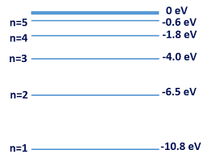
The figure at right illustrates some of the valence electron energy levels in a gaseous atom of a particular element. The energies of the levels are given in electron volts (eV).

(a) The valence electron of the atom is in the lowest energy level shown. What is the ionisation energy of the atom in joules? (2 marks)

(b) State two physical processes by which an electron in the ground state can move to a higher energy level. (2 marks)

A cold gaseous sample of the element is bombarded by electrons of energy 9.5 eV and observed to emit electromagnetic radiation.
(c) Show on the diagram above all the energy level transitions that could emit electromagnetic radiation after the gas sample was excited. (2 marks)

(d) Calculate the longest wavelength of the emitted electromagnetic radiation. (3 marks)

Invisible ultraviolet light of photon energy 6.8 eV is shone through a cold gaseous sample of the element, which is then observed to glow with a turquoise-blue light.
(e) Calculate the frequency of the turquoise-blue light. (3 marks)

Question 22 (15 marks)
A mobile crane is used to lift a load m of mass 1600 kg, as shown in the diagram below. The 18 m long boom (crane arm) has a mass of 850 kg, centred halfway along its length, and can pivot about point P at its base.
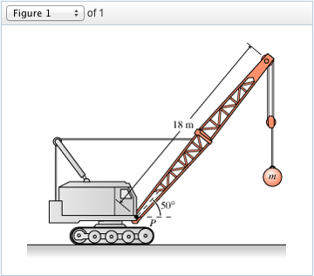

(a) Clearly show all forces acting on the boom as labelled arrows on the diagram. (3 marks)

(b) A horizontal steel cable connects to the boom 8.00 m from the pivot P. Find the tension in the cable needed to hold the boom stationary. (4 marks)

(c) Determine the magnitude and direction of the reaction force provided by the pivot P on the boom. (4 marks)

(d) Describe how and explain why the tension in the steel cable must change as the boom is lifted to a more vertical position:
(i) at the instant the boom is first moved upwards from the position shown in the diagram above. (2 marks)

(ii) when the boom is held stationary again in a new more vertical position. You may consider the cable to remain horizontal and attached 8.00 m from the pivot. (2 marks)

End of Section Two
SECTION THREE: Comprehension and data analysis 36 marks (20%)
This section has 2 questions. You must answer both questions. Write your answers in the spaces provided.
Spare pages are included at the end of this booklet. They can be used for planning your responses and/or as additional space if required to continue an answer.
- Planning: If you use the spare pages for planning, indicate this clearly at the top of the page.
- Continuing an answer: If you need to use the space to continue an answer, indicate in the original answer space where the answer is continued, i.e. give the page number. Fill in the number of the question that you are continuing to answer at the top of the page.
Suggested working time: 40 minutes.

Question 23 PROJECTILE LAUNCHER EXPERIMENT 21 marks
A group of inquisitive Year 12 Physics students conducted an investigation into projectile motion where they used a projectile launcher to shoot a ball bearing off the edge of a table of height D, at a variety of different speeds. For each trial they measured its height h above the floor, after it had travelled a fixed distance s horizontally from the edge of the table, by videoing the ball bearing as it passed a meter ruler set up as shown below.

LAUNCHER
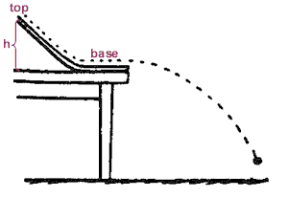
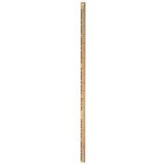

LAUNCHER

D

h

s

The table below shows the data they gathered over several trials, where they used successively larger launch speeds u and measured the height h at which the ball bearing passed by the ruler.

Launch speed u (m/s) | 1.6 | 2.0 | 2.4 | 2.8 | 3.2 | 3.6
Height h (cm) | 11 | 40 | 56 | 66 | 72 | 76

The general relationship between vertical displacement Y, horizontal displacement s and speed u for an object launched at angle θ to the horizontal is given by
$$Y=s×tan{θ}+\frac{gs^{2}}{2u^{2}{\left(\cos{θ}\right)}^{2}}$$
The relationship the students deduced linking speed u and height h for their experiment was
$$h=\frac{-4.9s^{2}}{u^{2}}+D$$

(a) Show how the students deduced their modified relationship. (3 marks)

(b) Using the extra rows provided, modify the data in the table so that a linear graph can be obtained using SI units. Give the modified data values an appropriate number of significant figures. (3 marks)

(c) Draw the linear graph on the graph paper on the next page. (an additional copy of the graph paper is available at the back of this paper if needed). (4 marks)

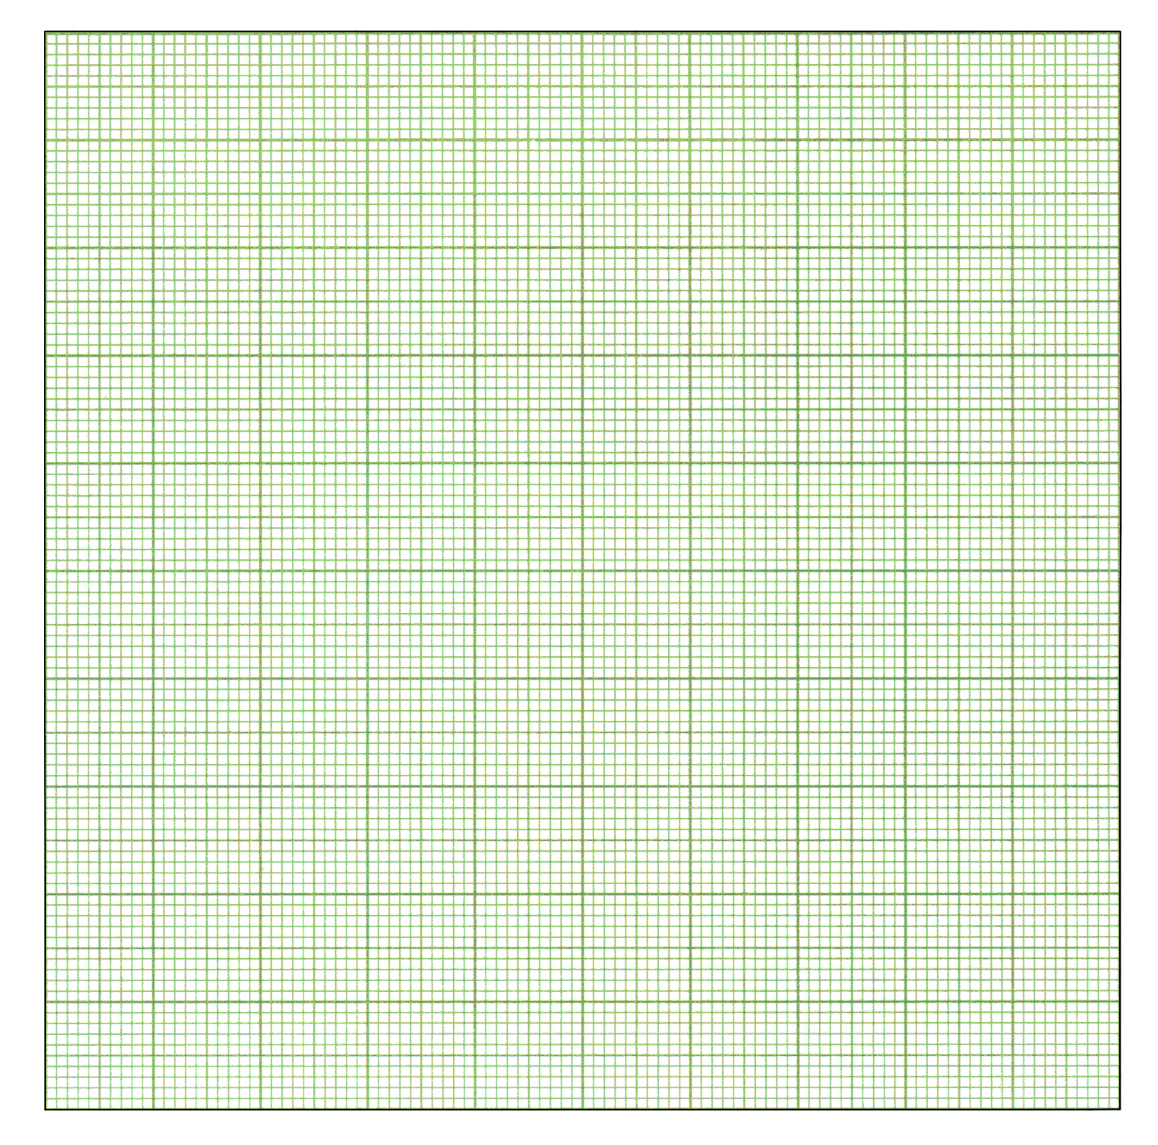

(d) The students estimated that their values for height h were accurate to ± 1 cm while the
launch speed u was accurate to ± 0.1 m/s. Use these estimates to calculate the uncertainty in both the vertical and horizontal variables and hence to plot error bars on the graph, for the point where height h = 40 cm only. (3 marks)

(e) Find the gradient of the graph. (3 marks)

(f) Hence calculate the fixed distance s that the ball bearing travelled horizontally from the edge of the table. (2 marks)

(g) From your graph, find
(i) the height D of the table (1 mark)

(ii) the minimum launch speed needed for the ball bearing to reach the metre ruler while still in the air (before hitting the floor) (2 marks)

Question 24 LASERS (15 marks)
(Paragraph 1)
The word 'laser' stands for 'Light Amplification by Stimulated Emission of Radiation'. A laser is an instrument made of a certain material that can be stimulated, by an external energy source, to emit light. Light from everyday sources, such as a light bulb, is produced in a haphazard process called spontaneous emission that gives an incoherent source of light (the photons have a random phase difference), which is then emitted in all directions.

(Paragraph 2)
In the Bohr atomic model, electrons orbit the nucleus with a definite energy, which increases with distance from the centre of the atom. Most atoms are in the ground state with electrons in the lowest energy level - this distribution is called a normal population. If energy is supplied to the atoms then electrons can be forced to higher energy levels (Figure 1) and the atoms are said to be in an excited state. For most substances the absorbed energy is emitted 'spontaneously' (Figure 2) in a very short time, typically less than 10⁻⁸ s, as a photon of energy hν.

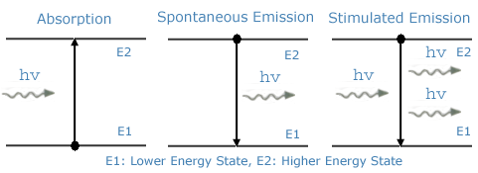
Figure 1 Figure 2 Figure 3

(Paragraph 3)
A laser on the other hand requires a substance that has a metastable state (an energy level in which an electron will remain for a time of the order of 10⁻³ s or longer) and atoms that are in an inverted population (more atoms are in the excited state than in the ground state).
These two conditions are necessary so that the process of stimulated emission can cause a coherent beam of light.

(Paragraph 4)
The stimulated emission process is shown above in Figure 3. When a photon of light of the same energy as the difference between the ground state and excited state hits an excited atom it causes the electron to fall back down to the ground state, emitting light of the same frequency that is in phase with the first photon and travels in the same direction. These photons strike other excited atoms causing an avalanche of photons with the same wavelength and in phase. A monochromatic laser beam is formed by having a resonating tube that has mirrors at each end, one fully reflecting, the other partially reflecting, which allows a small percentage of the photons to pass through.

(Paragraph 5)
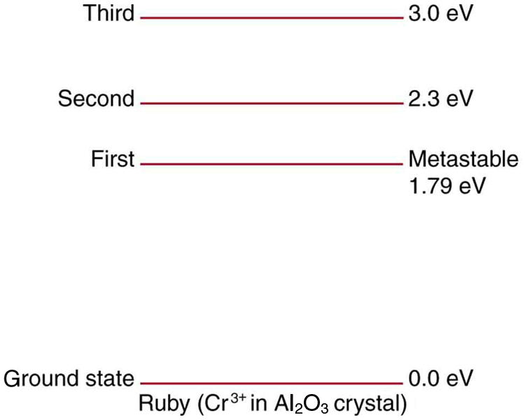
The excitation of the atoms in a laser can be done in several ways to produce the necessary inverted population. In a ruby laser, the lasing material is a ruby rod consisting of Al₂O₃ with a small percentage of aluminium (Al) atoms replaced by chromium (Cr) atoms. The Cr atoms are the ones involved in lasing. The Cr atoms are excited by strong flashes of light of wavelength 540 nm, which correspond to a photon energy of 2.3 eV. As shown in Figure 4, the atoms are excited from the ground state to the second excited state. This process is called optical pumping. The atoms quickly decay either back to the ground state or to the intermediate first excited state, which is metastable with a lifetime of about 3 x 10⁻³ s. With strong pumping action an inverted population can be formed. As soon as a few atoms in the metastable state jump down to the ground state they emit photons that produce stimulated emission and the lasing action begins. A ruby laser thus emits a beam whose photons have energy 1.79 eV and a wavelength of 694.5 nm (or "ruby-red" light).

Figure 4: Energy levels of
chromium in a ruby laser.

(a) What are the main differences between an everyday light source and a laser? (2 marks)

(b) Describe the difference between a normal population of atoms and an inverted population of atoms. (2 marks)

(c) Using appropriate terminology as discussed in the article, briefly describe the two conditions that are necessary for stimulated emission to take place. (3 marks)

(d) How does the stimulated emission process and design of the laser produce a coherent beam of light? (3 marks)

(e) Using a calculation to help support you answer, what part of the electromagnetic spectrum does the transition from the second excited state to the intermediate first excited state in the ruby laser (Figure 4) correspond? What implication does this have on the operation of the laser? (3 marks)

(f) What is the theoretical maximum efficiency of the ruby laser? (2 marks)

End of Section Three - End of Questions
Additional Working Space

Additional Working Space

Additional Graph Paper



